**PREMIER SUPERMARKET SALES ANALYSIS DASHBOARD & REPORT**

## INTRODUCTION

For every business, data is the building block. Behind every transactional system, data is actually the main by product. Like how a blood test can help the doctor diagnose you, a simple data test tells you what your business is doing statistically. Transactional data from Premier Supermarket Holdings helps paint the true picture of how good or bad things are in financial transactions,capital gain and customer outreach. This information is the basis of 90% of financial decisions. This help unravel hidden or unseen insights and also help come up with better strategies to increase growth and increase business success.

## DATA INFORMATION

The dataset was sourced from

[https://www.kaggle.com/datasets/aungpyaeap/supermarket-sales.](https://www.kaggle.com/datasets/aungpyaeap/supermarket-sales.                       )

The data contains the following columns:

1. **Invoice id**: Computer generated sales slip invoice identification number
2. **Branch**: Branch of supercenter (3 branches are available identified by A, B and C).
3. **City**: Location of supercenters
4. **Customer type**: Type of customers, recorded by Members for customers using member card and Normal for without member card.
5. **Gender**: Gender type of customer
6. **Product line**: General item categorization groups - Electronic accessories, Fashion accessories, Food and beverages, Health and beauty, Home and lifestyle, Sports and travel
7. **Unit price**: Price of each product in $
8. **Quantity**: Number of products purchased by customer
9. **Tax**: 5% tax fee for customer buying
10. **Total**: Total price including tax
11. **Date**: Date of purchase (Record available from January 2019 to March 2019)
12. **Time**: Purchase time (10am to 9pm)
13. **Payment**: Payment used by customer for purchase (Cash, Credit card and E-wallet)
14. **COGS**: Cost of goods sold
15. **Gross margin percentage**: Gross margin percentage
16. **Gross income**: Gross income

## OBJECTIVES

The main objective are:

1. To create a dashboard that show hidden insights in the data provided to help make dat-driven decision.
2. to show the true transactional summary of the business by illustrating how different factors are contributing to the growth.
3. To showcase areas that need corrections and prompting the strategies to better them which will positively impact the establishment.

## MISSIONSTATEMENT

Premier Supermarket Holndings contracted us to do a thorough drill down on why they were performing as they currenttly are. The best solution lied in taking a look at their data. Below are our findings detailed in this report.

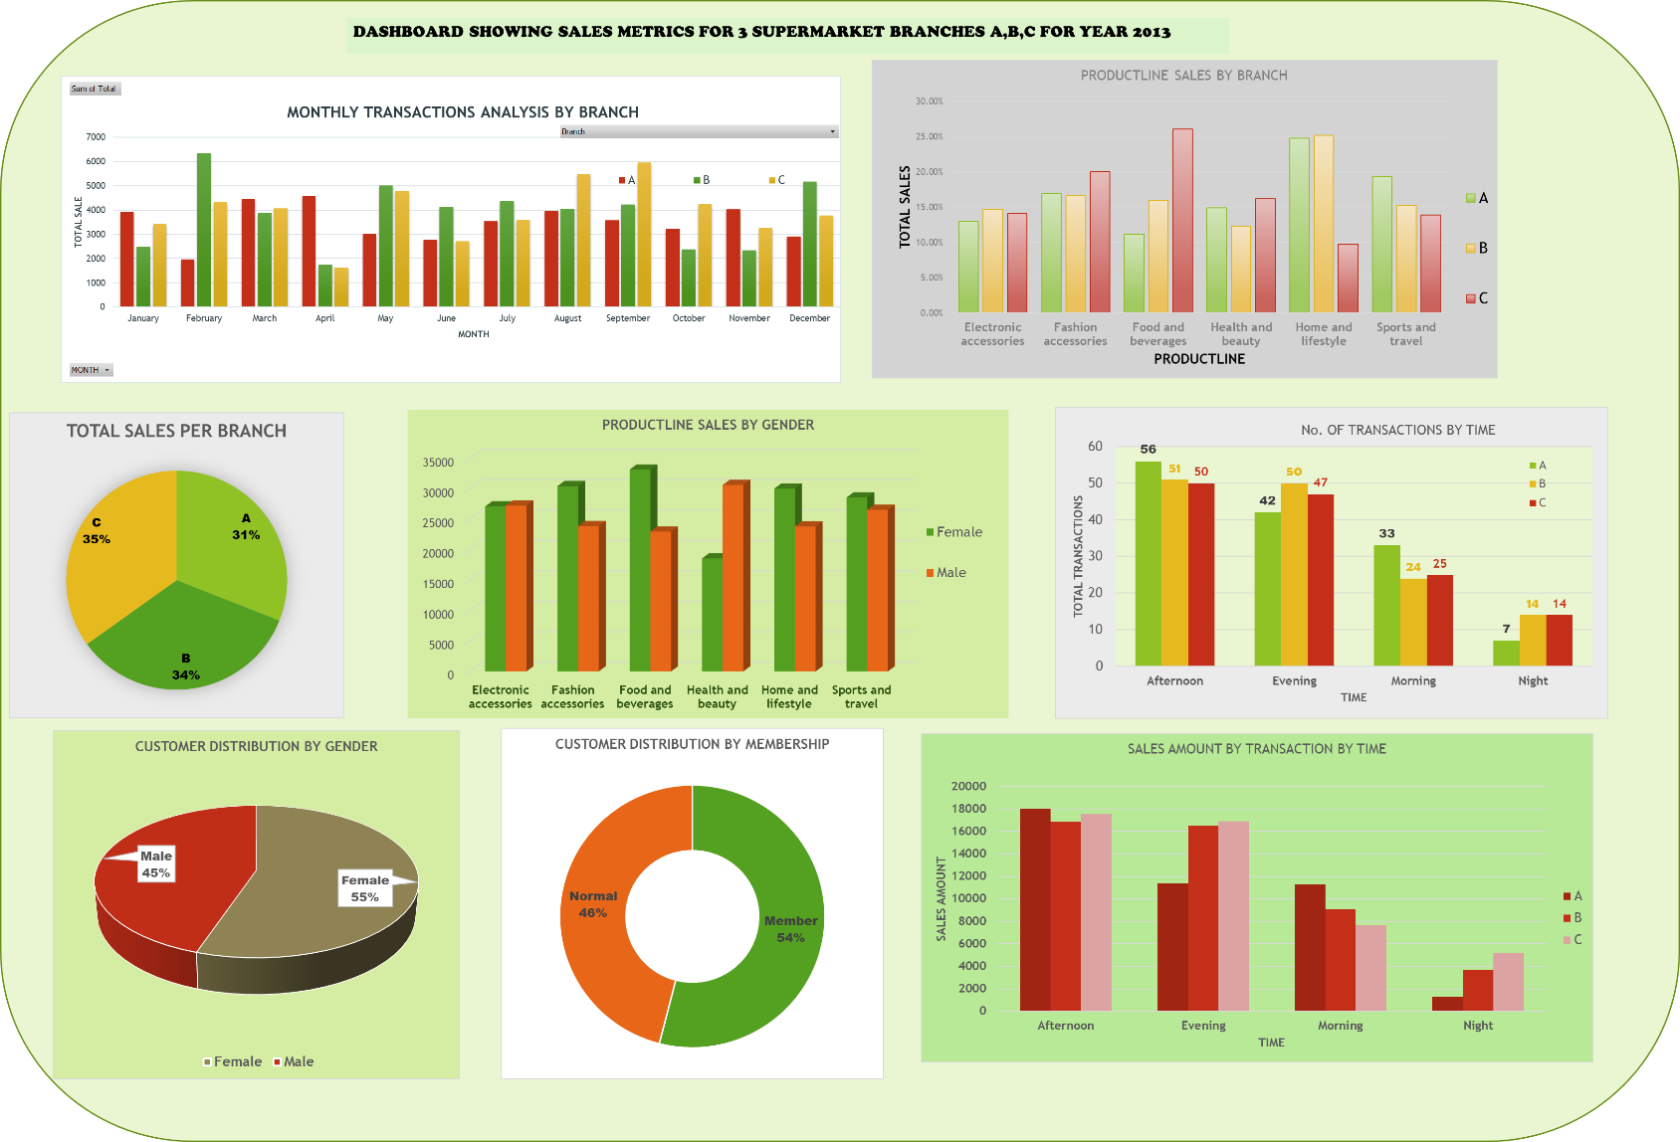

## KEY INSIGHTS

1. Branch B has the highest sales in Home and Lifestyle (25% of total sales) products followed by Branch A (24% of total sales).
2. Branch C has the highest sales in Food and Beverage (26% of total sales) followed by Branch B (16% of total sales).
3. Branch A excelled in sales of Sports, travel, home and lifestyle attributing to 43.9% of the total sales in the branch.
4. Sales are highest during the afternoons and evenings compared to during the day and at night (lowest).
5. Fashion accessories, food and beverage lead to 46% of sales in Branch C.
6. Electronic accessories were the least bought products contributing only 13% in total sales.
7. Females bought more fashion accessories, food and beverage than male customers.
8. The number of male customers was lower by 5% compared to female customers.
9. Premium Members bought 4% more than non-premium members.
10. Sales were highest in the month of September and August.
11. The month of April saw the least number of sales.

## RECOMMENDATIONS

1. The Weekend Spa Day in Branch C contributed to the high Fashion accessories sales in the branch. This also helped increase the sales in Food and Beverage due to the traffic of customers especially ladies. Introduction of such or related programs in the other branches would help boost sales. Expansion of the dining section in Branch C would help increase the Food and beverage further by an estimated 15%
2. The program Premier Homes in Branch B that incorporated a whole living room arrangement with electronics helped push the sales of electronics, and living items. Such arrangements especially in Branch C would help strengthen the sales.
3. Female customers tended to be the highest customers of Food and Beverage products. Stocking shelves adjacent to them with female fashion items which they purchased less would help boost sales for the fashion accessories product line.
4. Premium Premier members had the highest sales compared to regular shoppers, having membership incentives and loyalty points would help boost the members to shop more. Review of the membership plans would also bring more non-members to the membership package which would help in increasing subscription to the membership plan.
5. To help boost sales, making one of the branches 24 hrs. would help in the boosting of nights sales. This can then be rolled out to other branches if positive feedback is realized.